IBMREPOSITORY:

ProjectDevelopmentPhase

|  |  |
| --- | --- |
| **Date** | 10 November2022 |
| **Team ID** | PNT2022TMID50435 |
| **ProjectName** | SmartFashionRecommenderApplication |

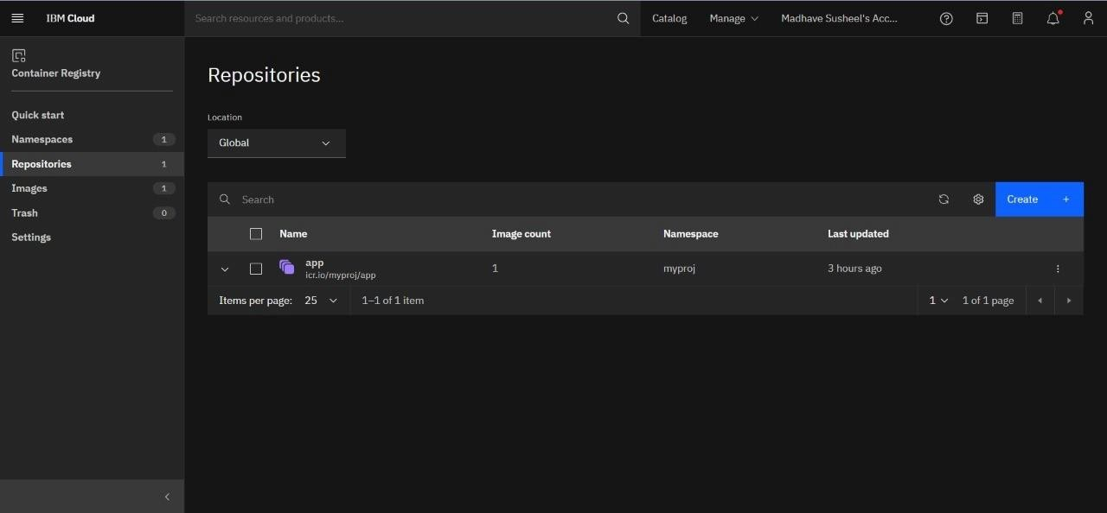

UPLOADIMAGEINIBMREGISTRY:

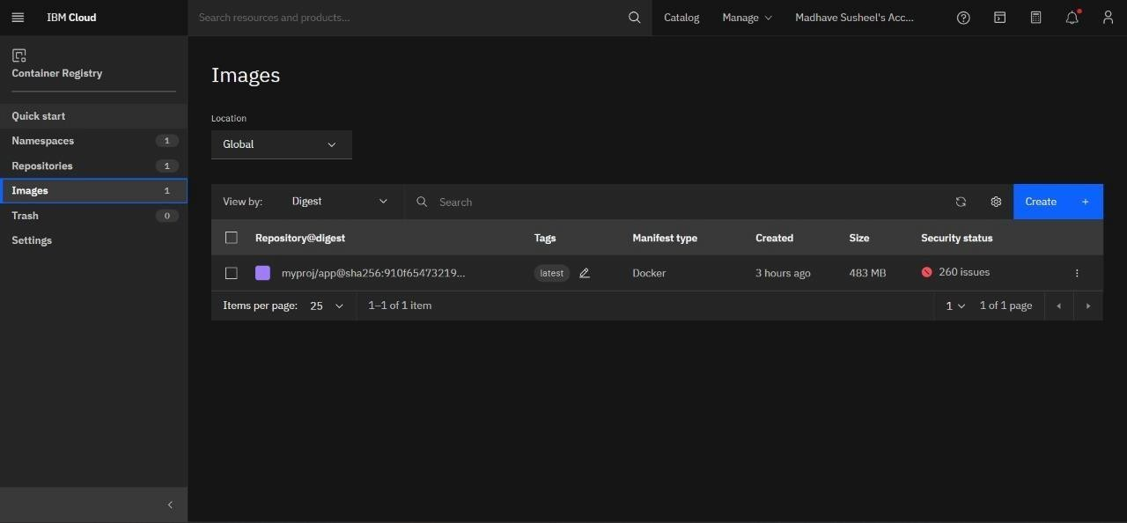

KUBERNETESWORKERNODE:

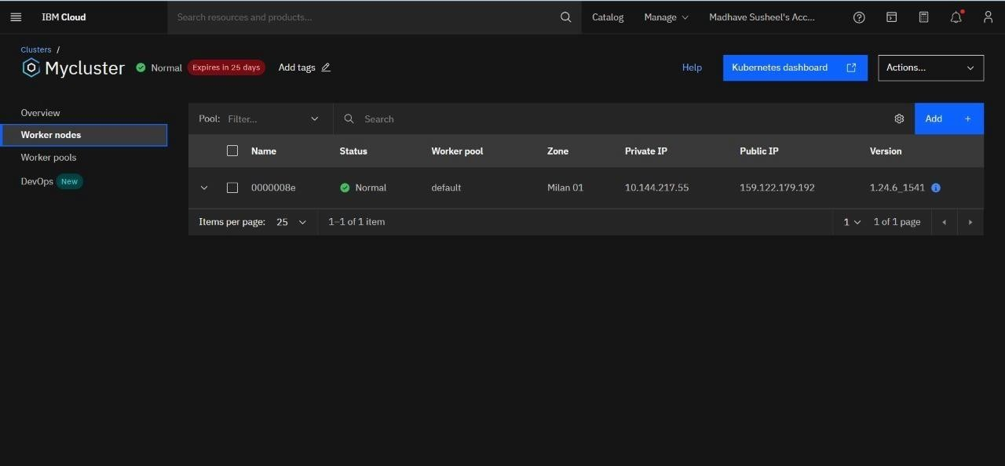

KUBERNETEDEPLOYMENT:

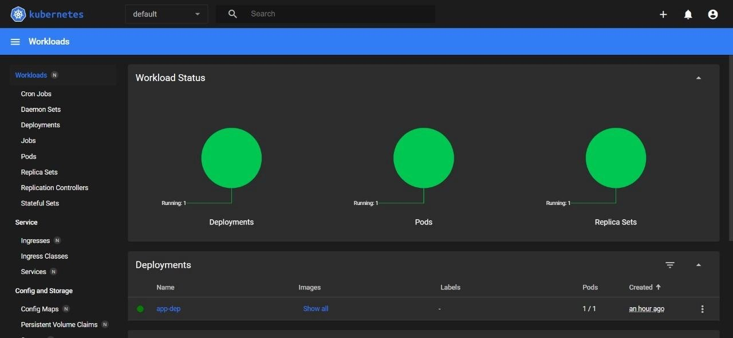

KUBERNETESERVICEPODS:

